Train 1

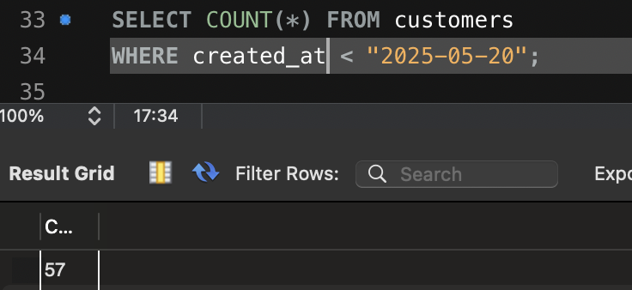
First, I started by using the SELECT statement above to see the number of users who signed up before the date of the campaign.
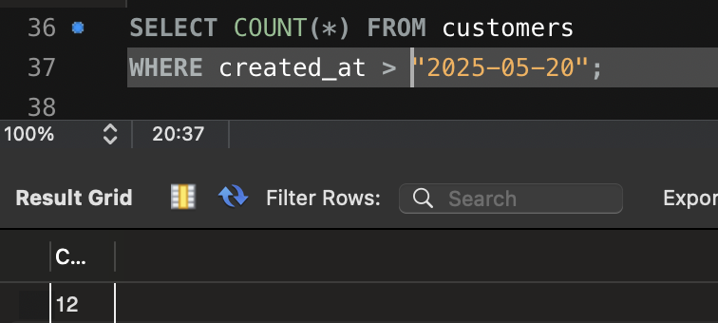
Then used the SELECT statement above to find the users that signed up after the campaign. After comparing the results from both statements, it appears significantly less people signed up after the campaign which means the campaign was probably not very effective.

- 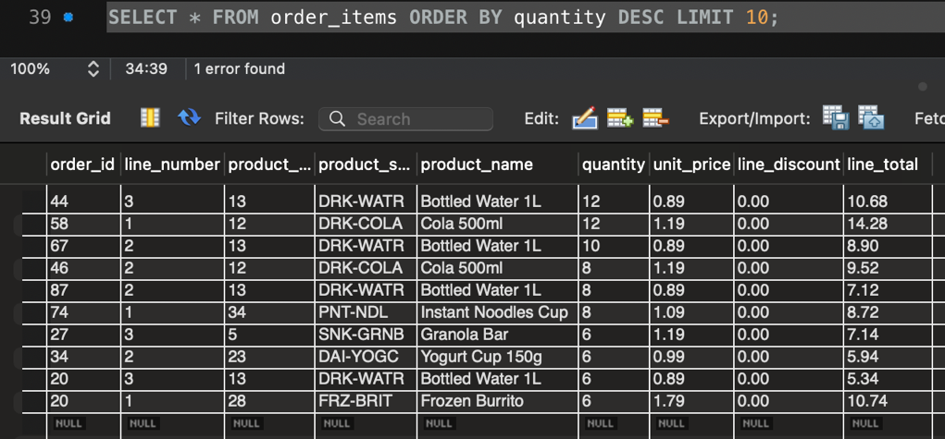
First, I started by using the statement above to see the top 10 items purchased by large quantities using desc.
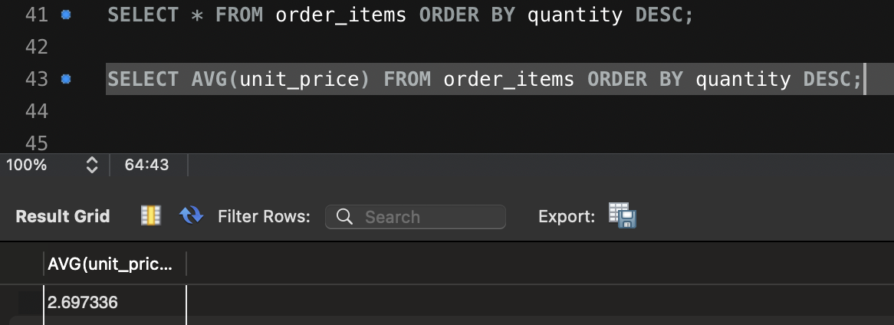
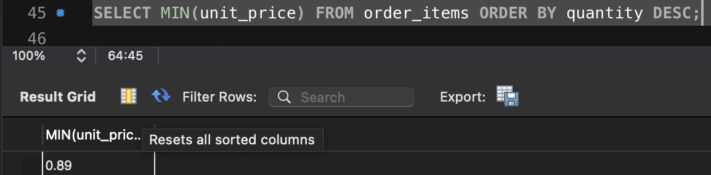
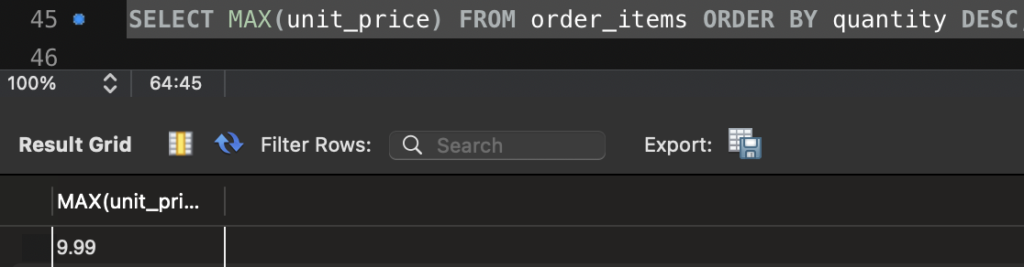
I then used the statements above to calculate the average unit price, MIN unit price and MAX unit price for all total products from the shop to compare with our table of the top 10 unit prices. One observation that can be seen from comparing is that the top 10 items include the MIN unit prices and are all relatively low compared to the average and nowhere near the max.

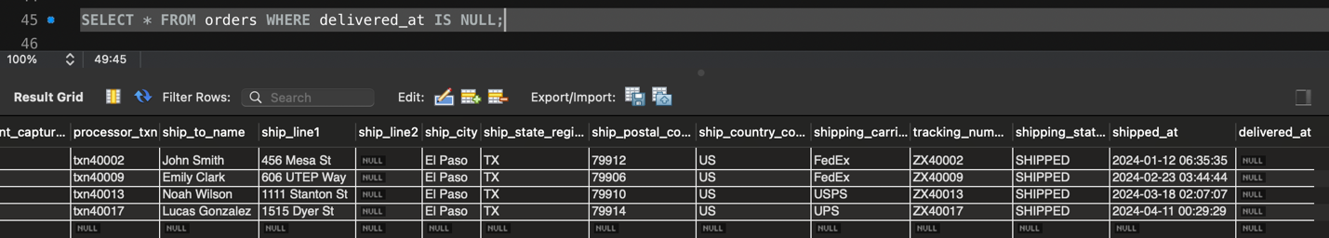
First, I used the statement above to find the orders that have not been delivered and it turned out to be 4.
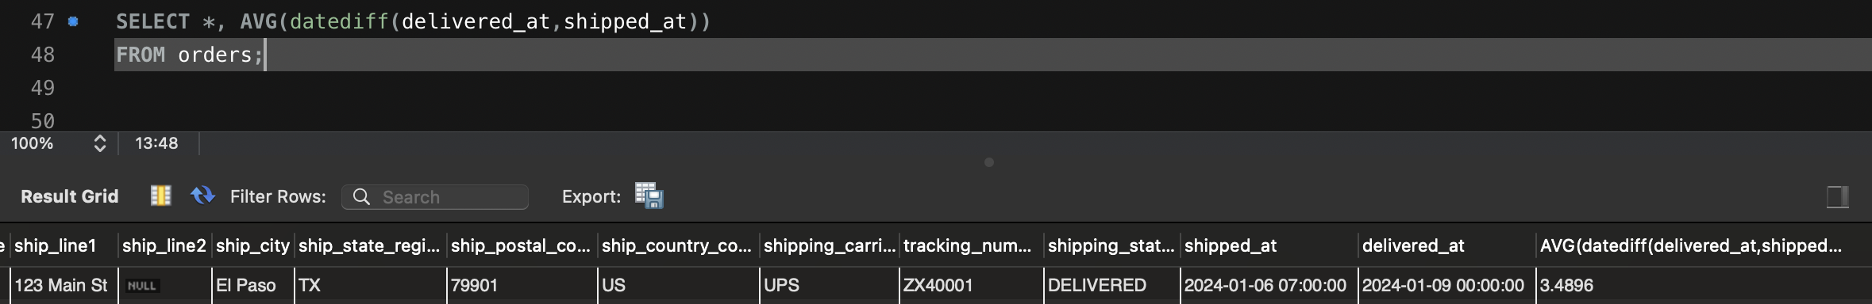
I then used the diffdate function with AVG to find the average time it usually takes orders to arrive which ended up being 3.5 days.
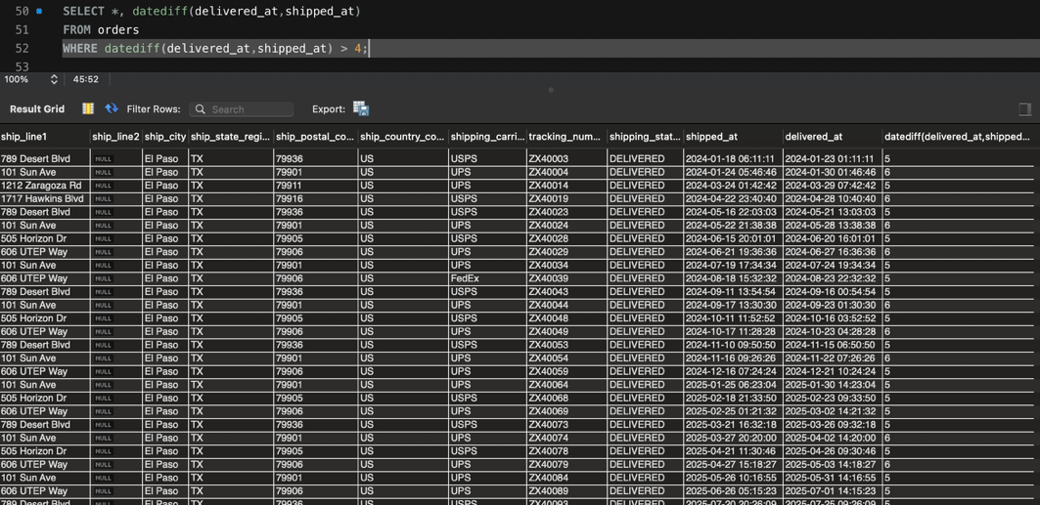
Using the prior information from the previous AVG I used it to find all the orders that took longer than 4 days to see which orders took longer than average to arrive to customers which ended up being 30 orders. I recommend that they implement into the database that nulls are not allowed for delivered column therefore it forces the company to make sure the orders are delivered and get reminded to check on the status before it’s too long. For long deliveries I recommend they implement something where after 4 days an order gets flagged so they can immediately check the order status and keep the customer informed as to why their order is delayed.

